Ryan Bleile

Ankit Adlakha

**Gold Ball (Projectile Motion) Report**

The projectile motion of a golf ball, with lift and drag friction, has been simulated using the Euler and Runge-Kutta 4 integration techniques. We ran a series of experiments to probe the initial conditions and answer the following two questions for our golf ball.

(a) optimal launch angle for a launch velocity of 60 m/s and a rotational velocity of 3000 rpm.

(b) optimal launch velocity for a launch angle of 20 degrees and a rotational velocity of 3000 rpm.

In order to answer these questions we ran 100 simulations across a range of values and targeted the point of interest.

We visualized the xy positions of the ball as it moved through space as well as recorded the landing distance for each run. From these we were able to plot angle versus distance and velocity versus distance curves. Using these curves we were able to find the optimum velocity/angle for maximum horizontal distance.

Outcomes:

Using an extra for loop around the simulation loop we were able to run this simulation to find the optimum launch velocity of 60 m/s at a rotational velocity of 3000 rpm. The conclusion of the experiment ended up being

Initial Velocity: 220

Distance: 333.398549476

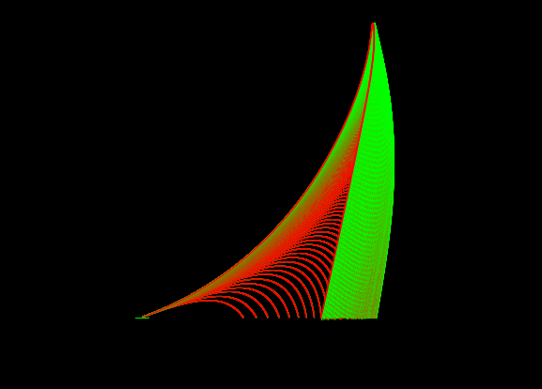

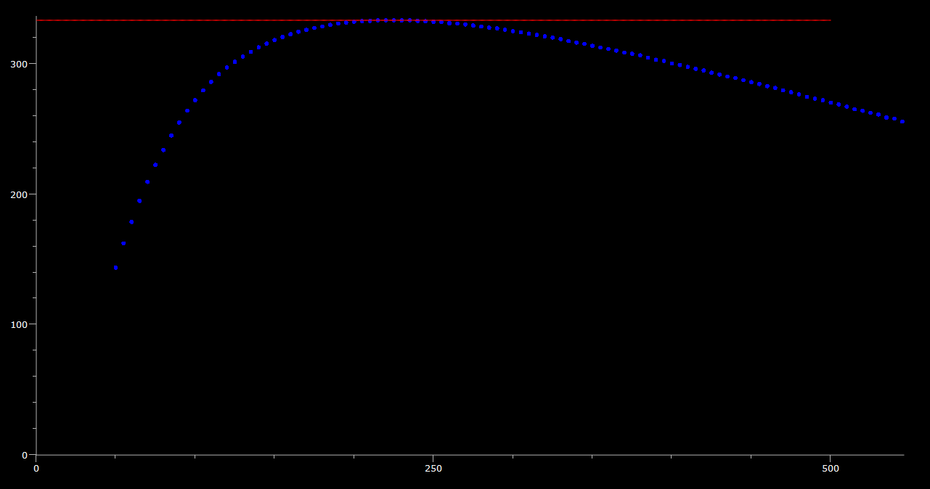

Using an extra for loop around the simulation loop we were able to run this simulation to find the optimum launch angle for a launch angle of 20 m/s at a rotational velocity of 3000 rpm. The conclusion of the experiment ended up being:

Angle: 17

Distance: 179.574251943

